Project Spyn Milestone 4 - Lift Mechanism
Robot Photo:
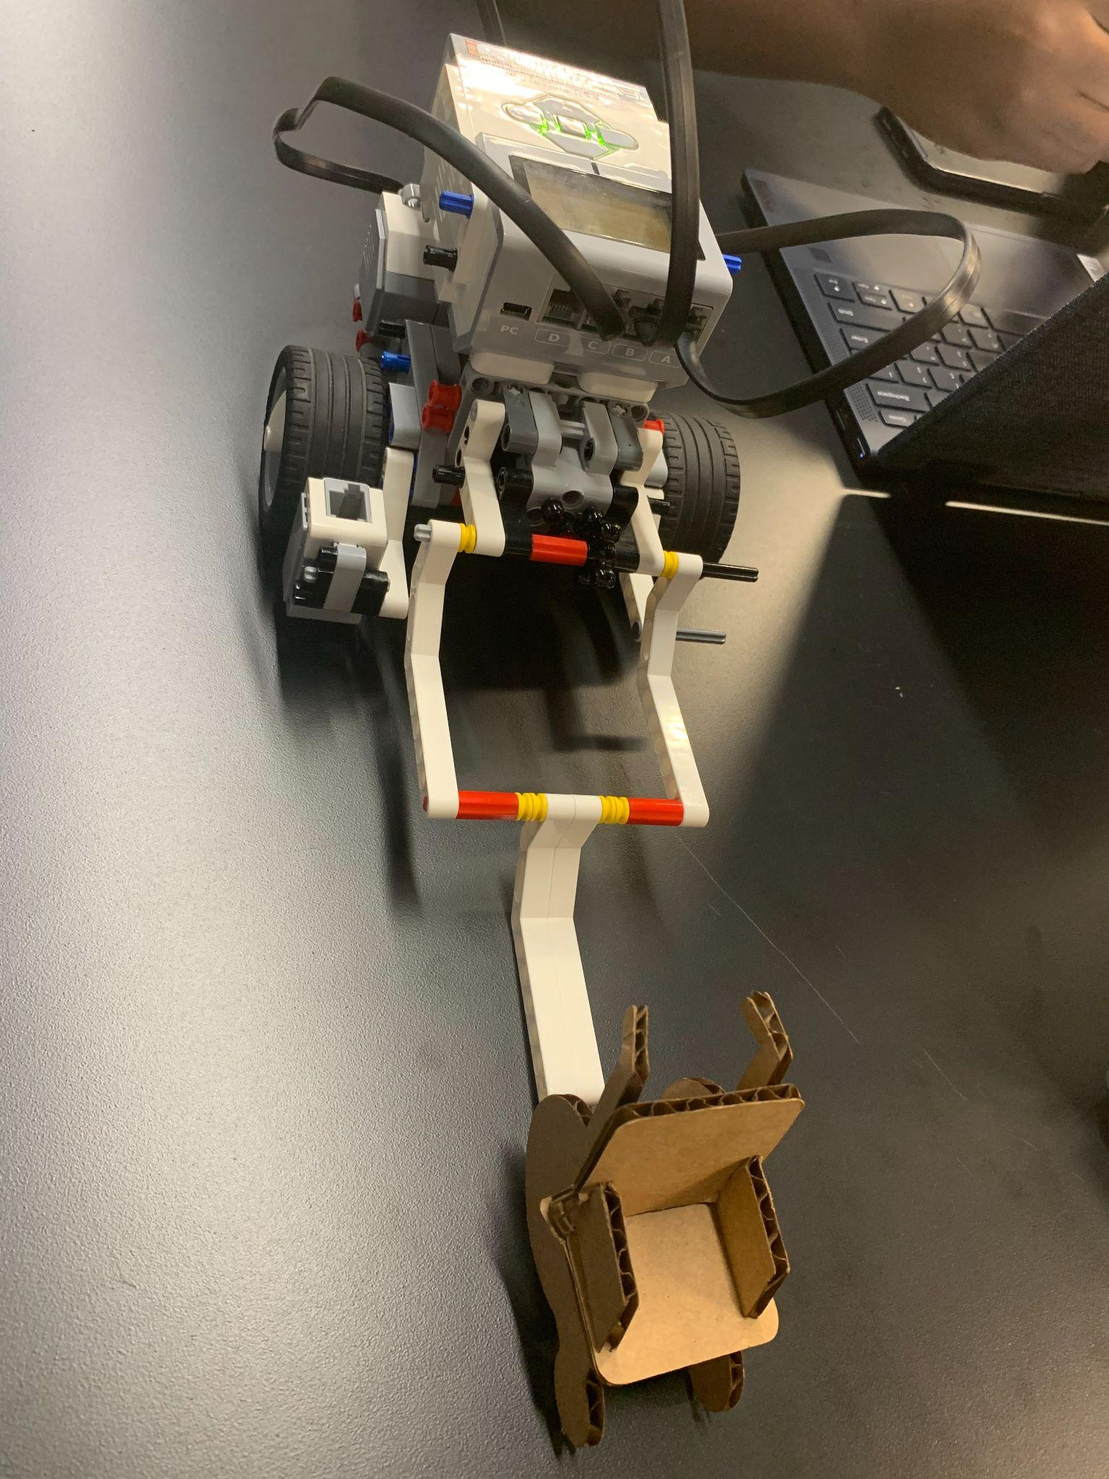

MATLAB Code:
Simulates driving towards the passenger, picking him up, and dropping him off.

brick.MoveMotor('C', 25);
brick.MoveMotor('B', 25);
pause(2);
brick.StopMotor('B');
brick.StopMotor('C');
brick.MoveMotor('A', 15);
pause(4);
brick.StopMotor('A');
brick.MoveMotor('A', -5);
pause(4);
brick.StopMotor('A');
brick.MoveMotor('C', -25);
brick.MoveMotor('B', -25);
pause(3);
brick.StopMotor('B');
brick.StopMotor('C');

YouTube Video:
https://youtu.be/DE9KU94OnPY

